Haley Eakin

September 16th, 2018

Homework #1

**Nomadic Matt Travel Blog**

[www.nomadicmatt.com](http://www.nomadicmatt.com)

The Nomadic Matt website is a travel blog that features guidebooks about travel destinations as well as travel resources and information from the perspective of an individual who has backpacked the world extensively. The purpose of this website is to provide users with information about how to travel well and cheaply. The audience of the Nomadic Matt website are travelers and people interested in traveling as the website content is geared towards both people who are planning to travel or are currently traveling. The Nomadic Matt website is a reliable and trustworthy resource since is updated frequently to include current and relevant information on costs, best places to visit, world events, and new places that Matt has traveled to.

**Examples of Good Web Design:**

1. 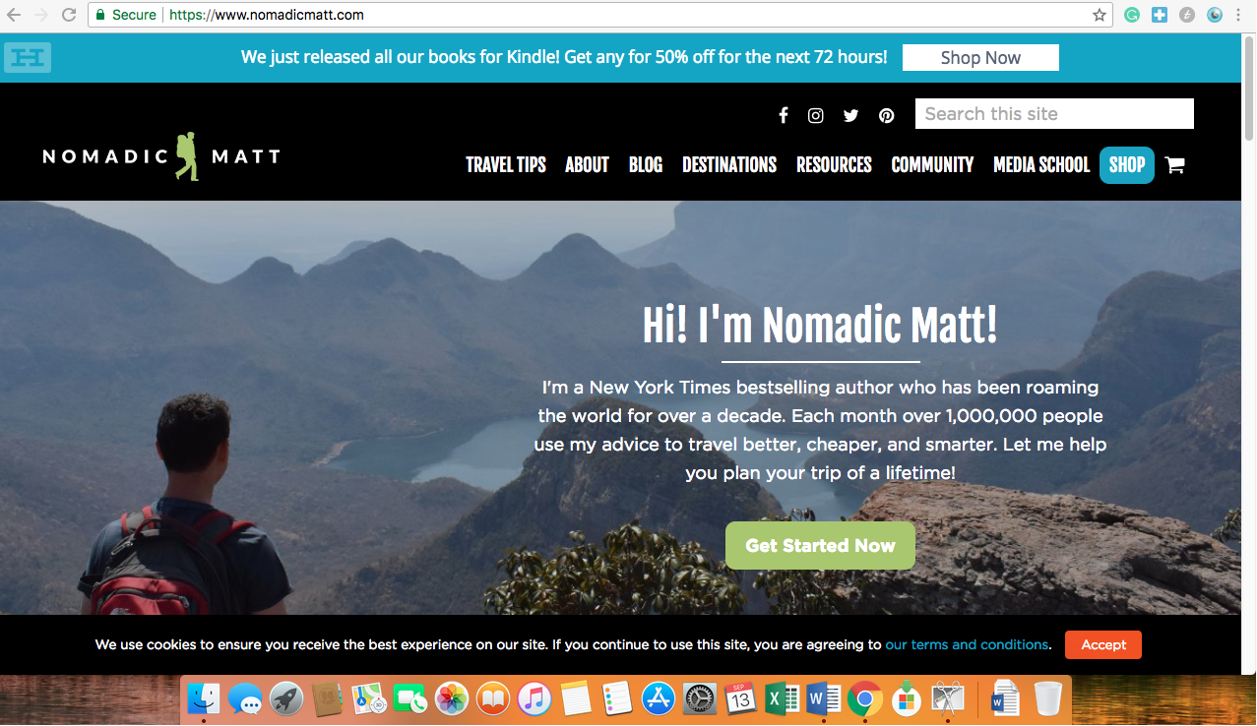**Great Usability:** The Nomadic Matt website has great usability. Navigating the website was nearly effortless since there are many straightforward avenues to accessing content. The search bar and menu with dropdowns across the top of the website allow users to navigate to different sections of the website like the about page, blog, destination guides, and resources easily.

The menu at the top of the page provides helpful categorization of content with dropdowns menus for further navigation.

Search bar is visible and in a standard position on the page, making it easy to find and use. In addition, it produces relevant results.

1. 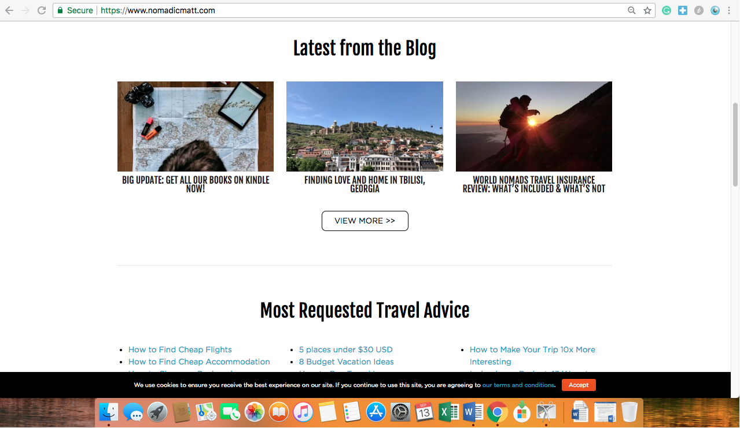**Targeted to Audience Needs:** The website performs exceptionally in being usable and engaging to many different kinds of travelers. The website does well at providing meaningful information to subcategories of their travel audience, including content that directed towards budget travelers, LGBTQ travelers, women travelers, and more. This information is located throughout many areas of the blog including the blog posts, travel tips, and destination guide sections of the website so that these users can easily find information that is relevant to them. In addition, this website serves both frequent and new users well. While the search navigation bars and menus provide users with the tools needed to find the information they want fast, the landing pages include clickable previews of top content such as “Most Requested Travel Advice” and “Latest Blog Posts” to drive new users that are not exactly sure of what they are looking for to content that will most likely interest them.

On the website landing page, these sections allow casual users and new users to easily find content that interests them while search and menu bars at the top of the landing page provide frequent users and users looking for specific content to quickly access the content they are interested in.

1. **Good Feedback:** The Nomadic Matt website provides great feedback to users. I never felt lost on the

website because each time I searched for specific content, I was provided with feedback at each click that reassured me that I was getting closer to accessing the information I wanted or that needed to

reroute. Furthermore, the website is responsive. Unlike similar travel websites I have used, this site loads 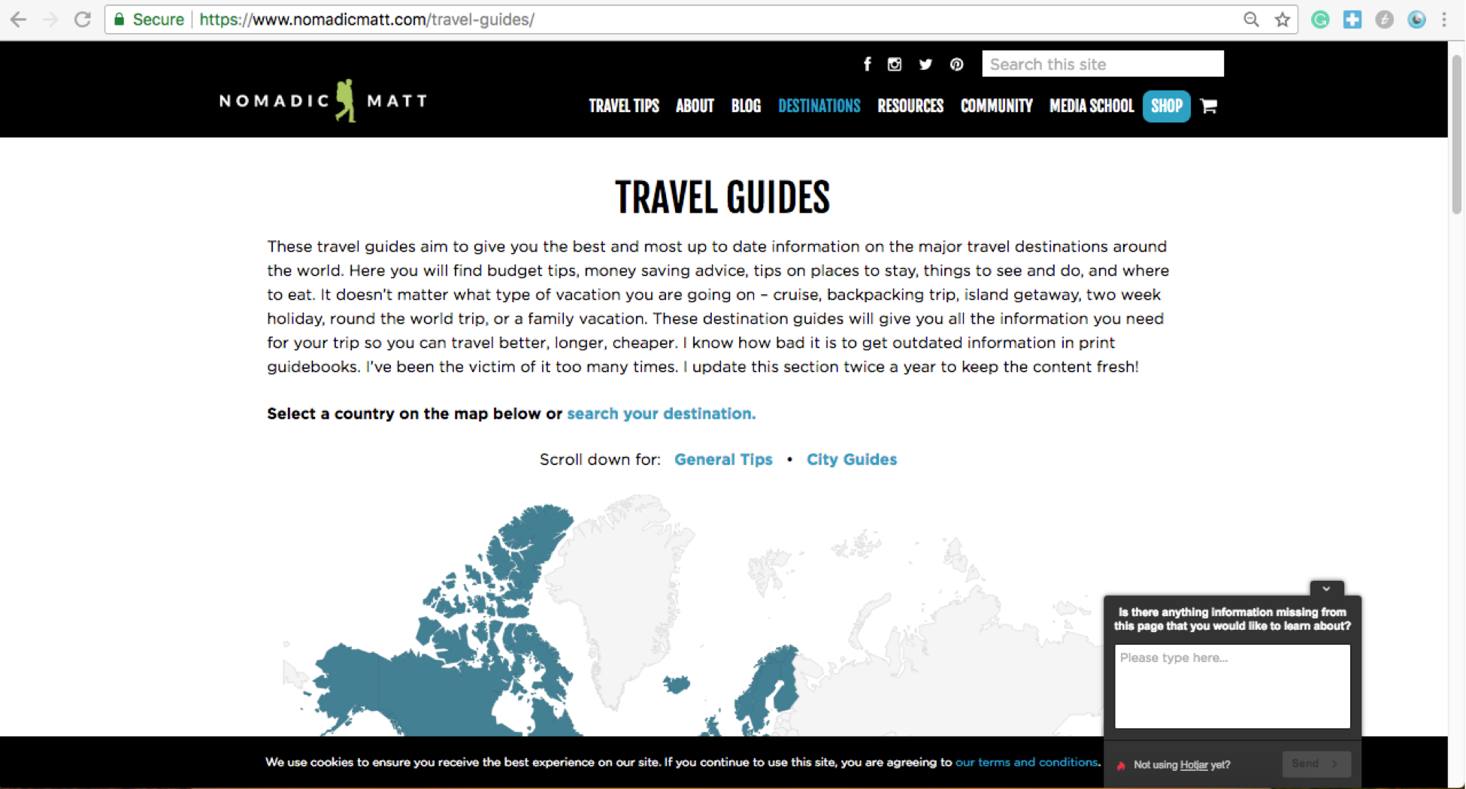quickly and reliably. All the links I tested worked properly and delivered me to useful information.

1. Clicking on “Destinations” brought me to a page titled “Travel Guides” with an interactive map of the world underneath. By receiving this feedback, I was able to quickly figure out that by clicking on Cambodia in the map I would access a travel guide for Cambodia.

Example of good feedback:

1. In searching for information about traveling in Cambodia, I clicked on the “Destinations” in the menu.

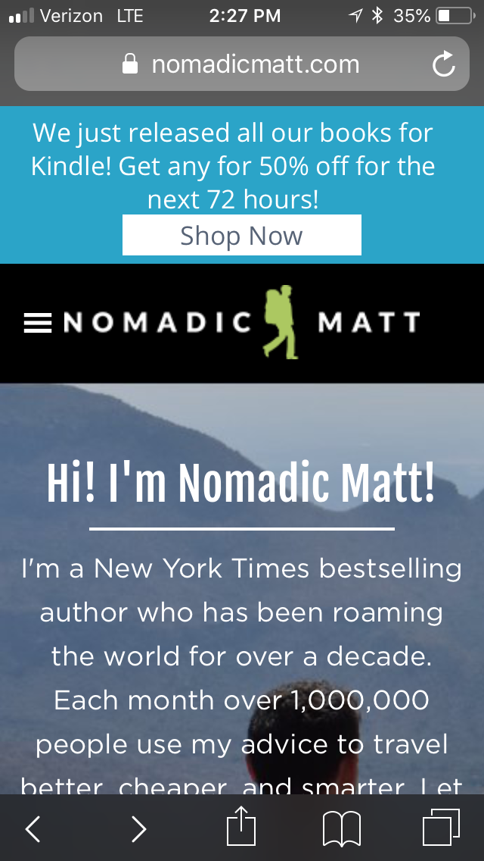

Each page of the website includes blue hyperlinked text like this that connects users to more relevant content.

1. **Dynamic Sizing:** The website automatically resizes itself to fit the screens of phones, computers, and differently sized web browsers, which is a great design feature that allows all types of users to access the website with great functionality on any device.

On a mobile phone, the menu bar that lies across the top of a desktop screen becomes a hamburger menu. This menu stills provides simple and easy navigation throughout the website

1. 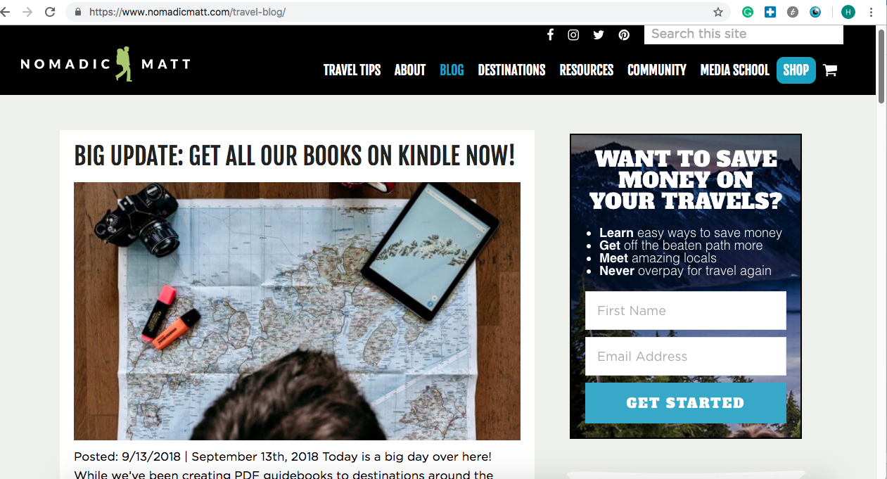**Visually Appealing Aesthetic:** The website uses colors and imagery in an engaging and cohesive manner. Additionally, consistent colors and branding symbols are used throughout the website. The fonts used are easy to read and coherent. The nice visual design of the website contributes to its usability as people want to spend time on websites that are visually pleasing.

The pictures used are cohesive with the colors and style of the website.

Green and blue branding colors are used consistently on the website.

**Re-Design Ideas:**

Although I find this website to be well-designed and user-friendly, there is areas of the website that could use improvement. The webpage could include more interactive content and captivating visuals including videos. For example, I would include rotating images or a video where the photo banner currently resides on the website landing page. Secondly, because the webpage hosts extensive blog content, I would change the “Latest from the Blog” section to have a slider so that users can easily view more blog posts. Furthermore, currently the “Most Requested Travel Advice” section on the landing page looks cluttered since this section is composed of solely hyperlinked titles. I would re-design this section into categories to reduce clutter and ensure that users could easily find the content the interests them most.

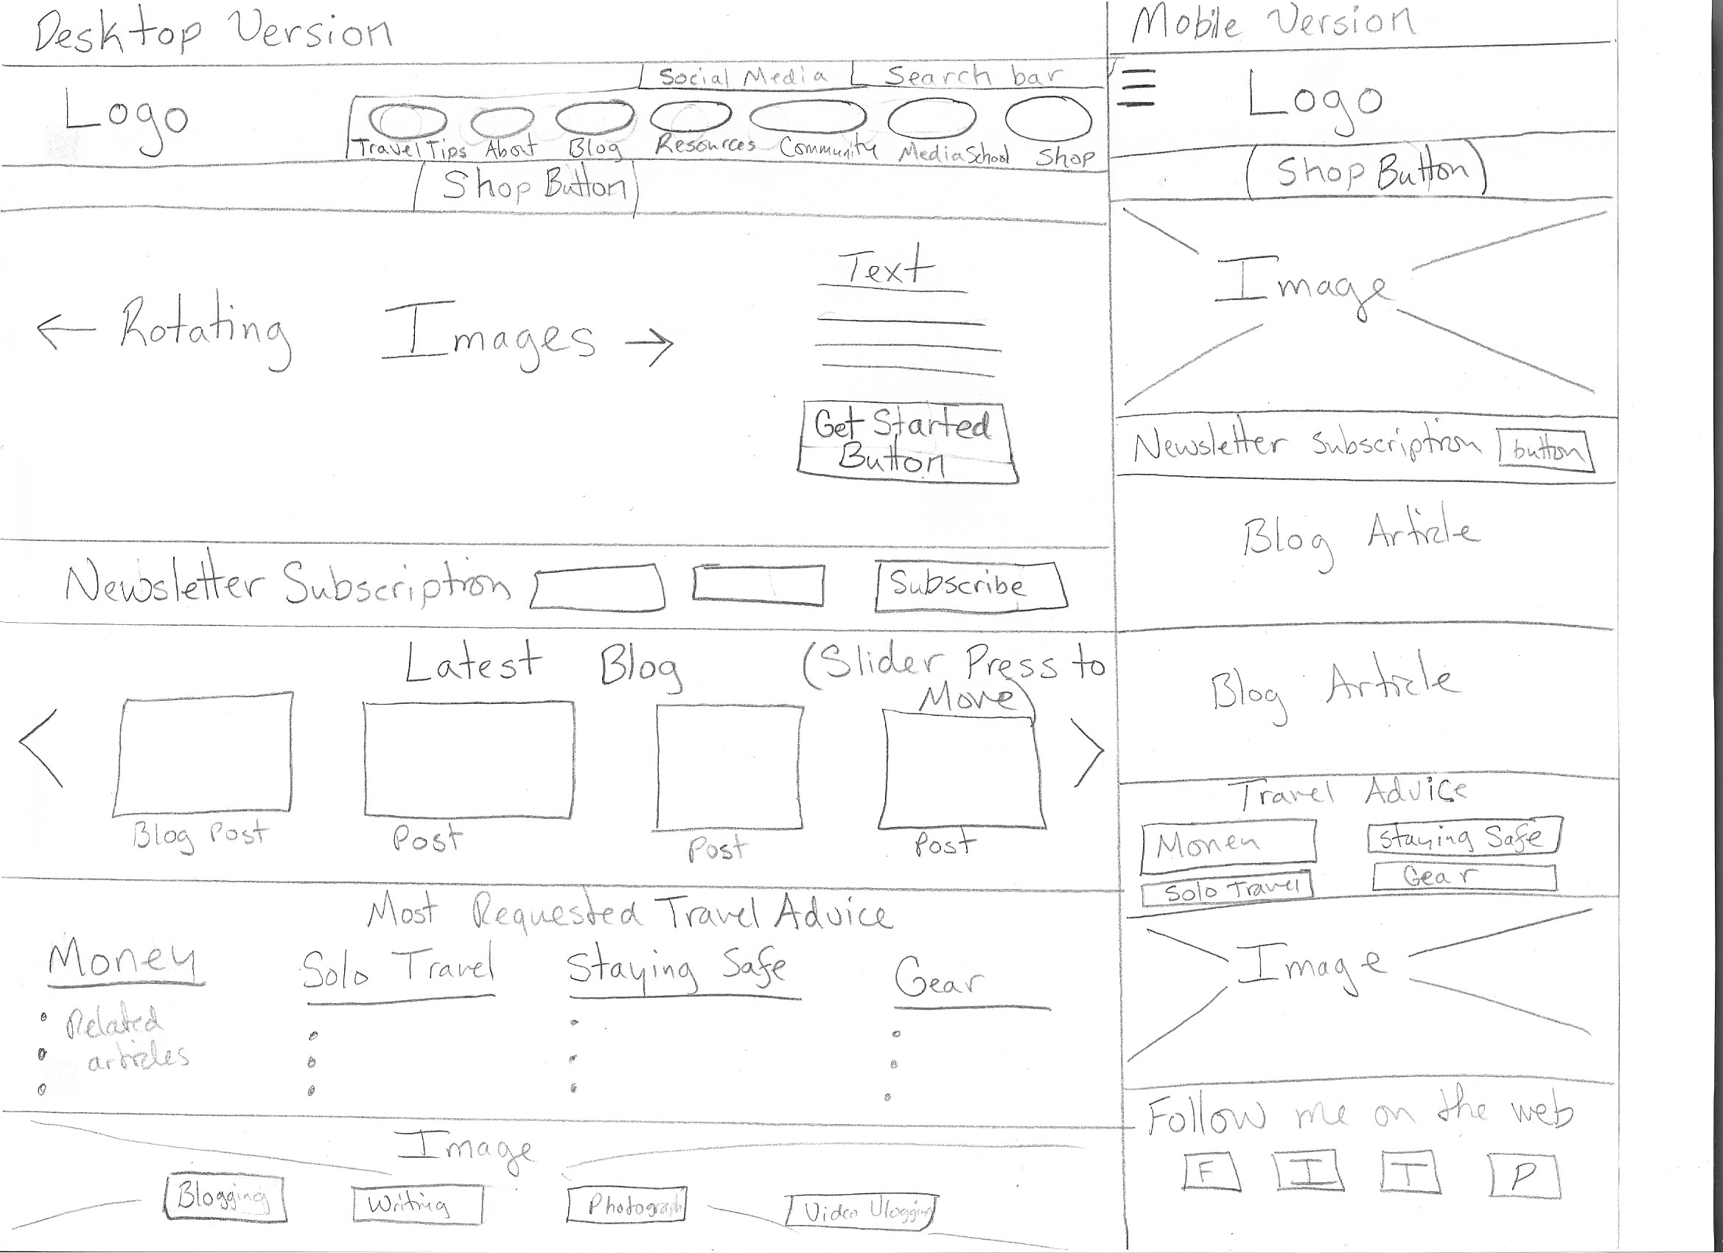

This section would be broken down into categories to improve ease of navigation and declutter this area of the landing page.

I thought the landing page of the mobile website page was overwhelming since it was filled with words, so I changed the top of the landing page to have no text overlaying the image.

This banner would include rotating images to improve the visual appeal of the webpage and make it more interesting.

Blog posts section would include a slider to display more content and increase user interaction with the webpage.

**Jeannette Rankin Peace Center**

[www.jrpc.org](http://www.jrpc.org)

This is the website of the local nonprofit, the Jeannette Rankin Peace Center. The audience of this website is Missoula community members who are members of the center or are interested in the center’s work. The purpose of the website is to provide people involved or interested in the Jeannette Rankin Peace Center with upcoming events, news, and resources related to the center’s work. Although I appreciate this nonprofit and want to follow their work, I find their website very difficult to navigate and gather information from.

**Examples of Poor Web Design:**

1. **Lack of Navigation Ease:** This website is challenging to navigate. It does not have the customary search bar in the top right corner of the site or anywhere else. With no search bar feature, one is left to click around the website to find the information. There is a menu with drop downs on the website, however, the drop downs are labeled in a vague and confusing manner. Furthermore, using the menu navigation often directed me to pages with no substantive or relevant information.

Menu items are labeled poorly, which confuses users when trying to navigate around the site. As a new user, I was confused as to what “Act” and “Fair Trade/Olive Branch” meant, when this should be apparent.

This is landing page of the JRPC website. There is not search bar in the standard position on the website nor anywhere else on the website.

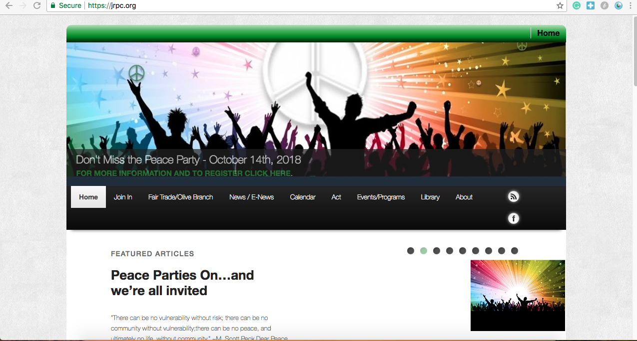

1. 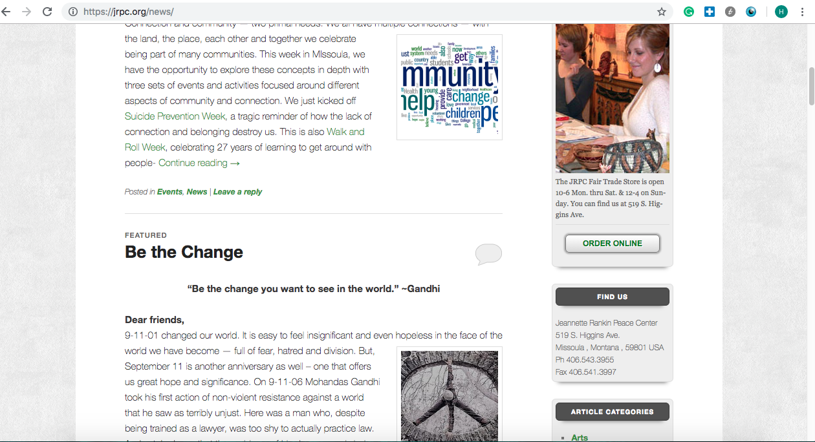**Outdated Visual Design:** There is a lack of color and innovative in the visual design of the site that makes it look outdated and boring. Although there is a consistent use of green, the website lacks color and branding cohesion. In addition, many of the pictures on the site are poor quality or outdated stock images. Lastly, it is confusing that there is no logo or the name of the organization on the website landing page.

On the “New Posts” page, old stock images are used alongside the blog posts. The image is incorrectly sized in the top blog post, leaving some letters cropped off.

1. 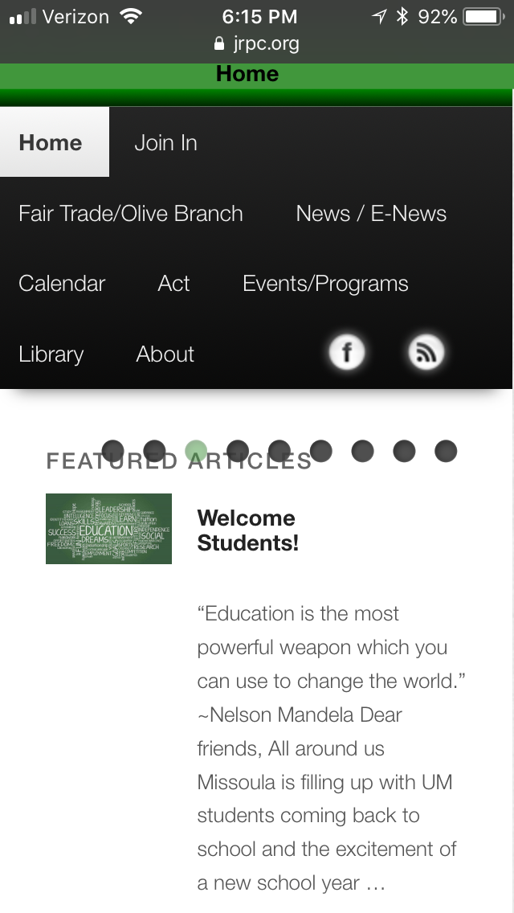**Lack of Dynamic Sizing:** The website appears to compatible with the size of desktop screens only. The site glitches on phone screens or when trying to change the dimensions of a web browser. When attempting to view the website in various sizes, parts of the website malfunction and overlap each other.

When viewing the website on an IPhone, the dots across the top of the screen overlapped the “Featured Articles” heading and obstructed the view.

1. **Poor Feedback:** The vague names on menu bar items and drop-down menus results in poor feedback for the user. When searching for information on the website, the headers and titles often did not help orient me and provide useful feedback on whether I was close to finding the content that interested me.

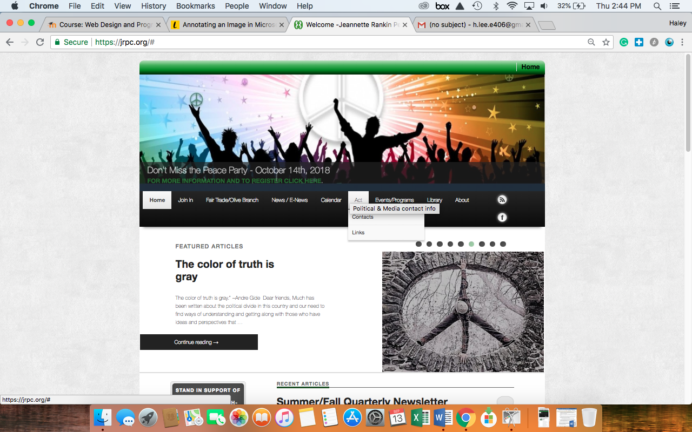

For example, in searching for ways to get involved and act, I hovered over the “Act” button in the menu. This brought up a dropdown menu with “Contacts” and “Links.” The vague names of the dropdown items did not provide me with the feedback needed to successfully find the information I desired.

1. **Poor Use of Screen Real Estate:** The Jeannette Rankin Peace Center’s website does not fully utilize its screen real estate, particularly on the website landing page. When users land on the website, they can only see the banner, menu, and portion of the “Featured Article” section. Scrolling down the landing page, there is a large portion of the page that is completely blank. This is prime real estate on the website and should definitely be optimized.

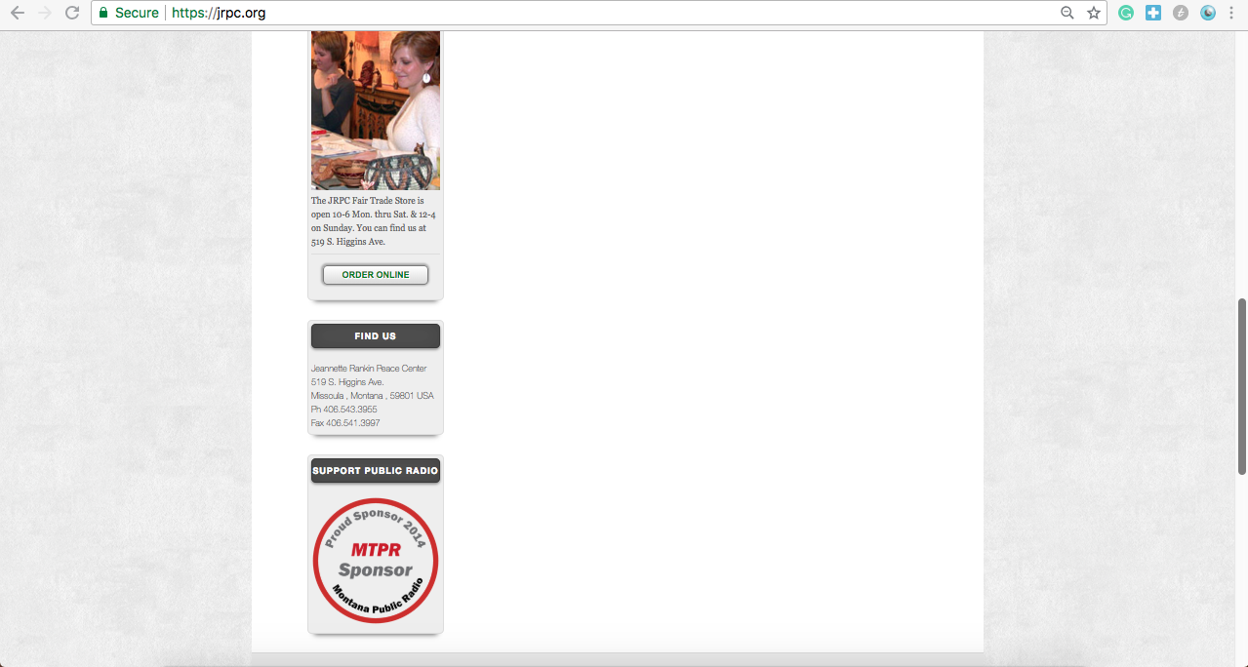

Throughout the website, there is unused screen real estate on either side of the webpage. These grey areas should be utilized.

This is a portion of the website’s landing page. Aside from the content on the left side of the page, it is blank.

**Re-design Ideas:**

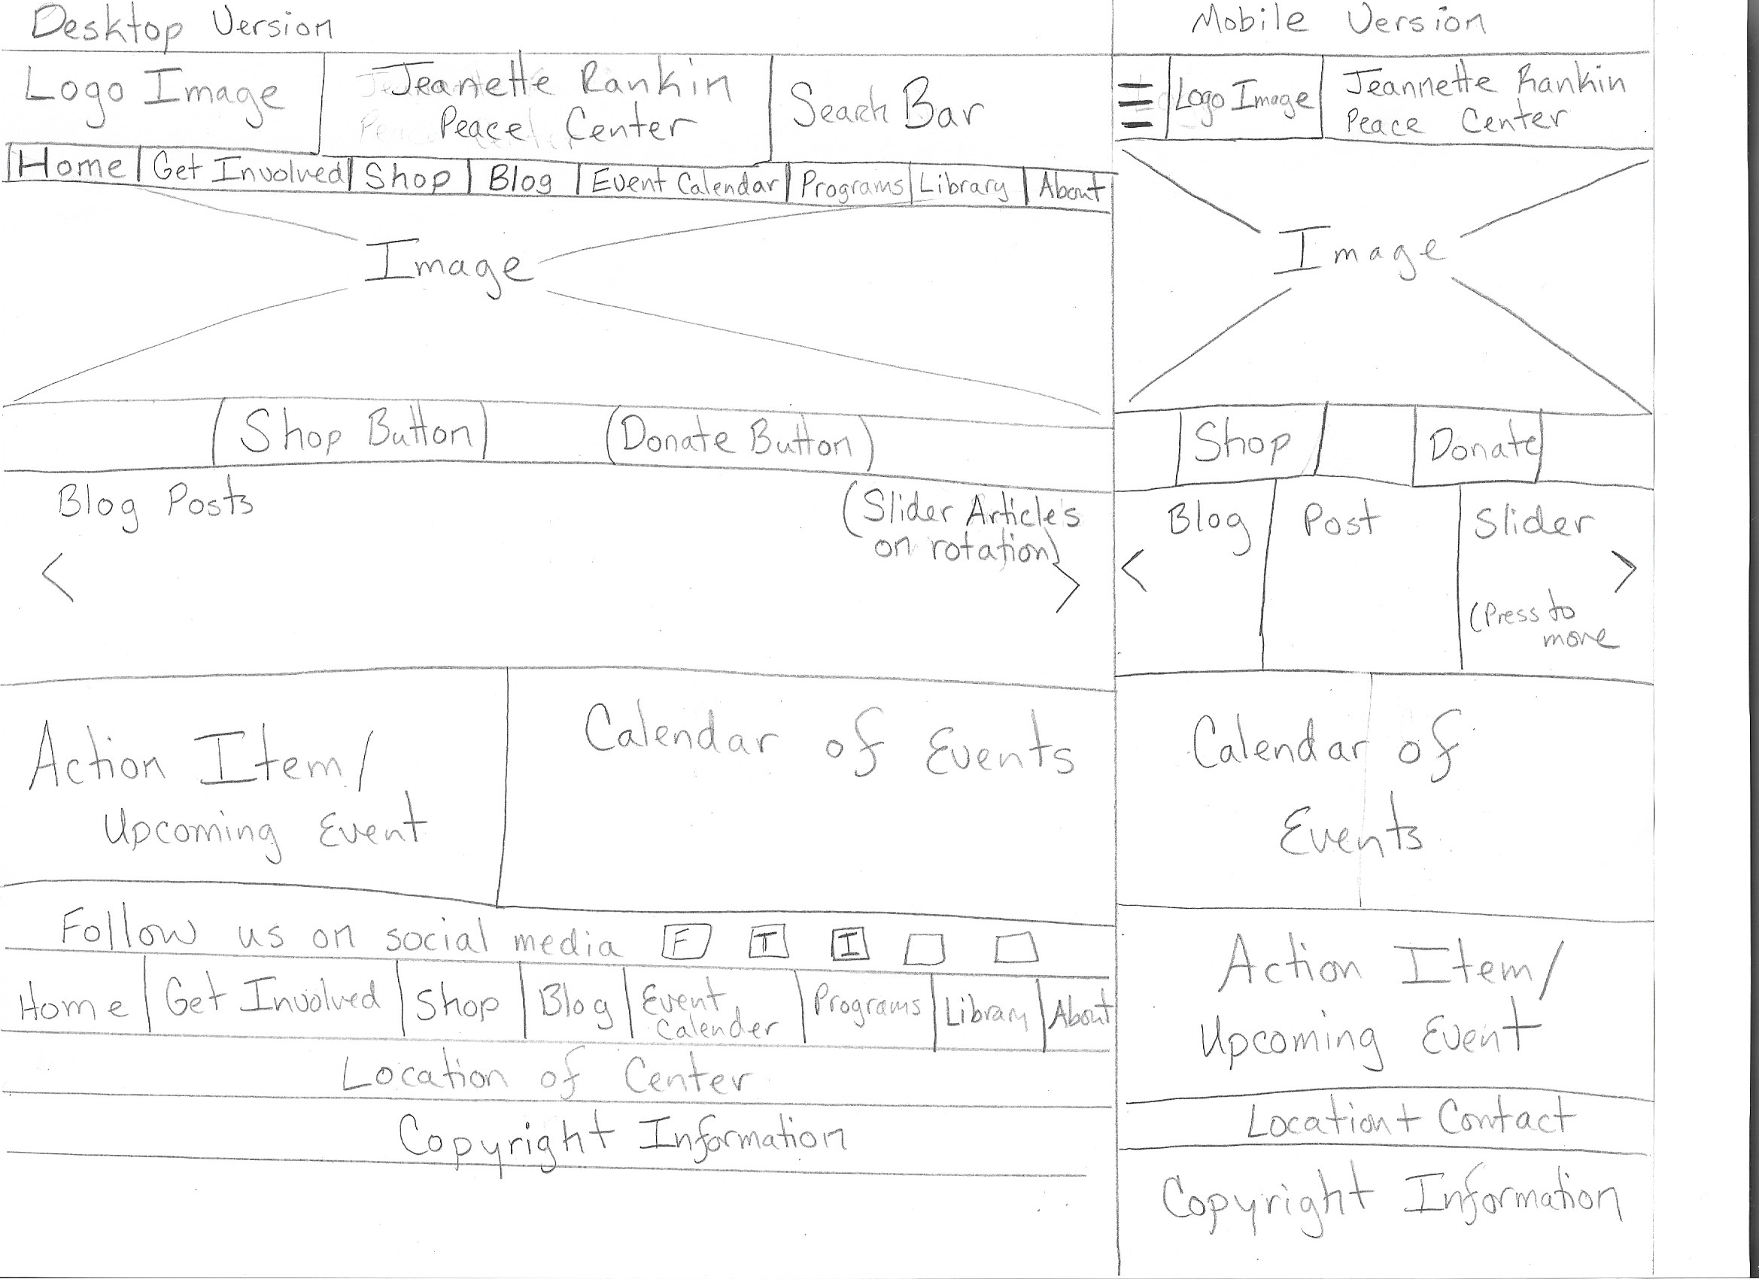To make the Jeannette Rankin Peace Center’s website more usable, I would change the re-design the aesthetic, navigation features, and sizing of the website. Firstly, I would change the visual aesthetic to liven up the website by updating photos and including more color. Secondly, I would change the sizing of the page so that the website content filled the screen to eliminate the underutilized scree real estate on the sides of screen and on the landing page as shown in the example above. To ensure the website was user friendly to mobile phones and all browsers, I would also make the website dynamically sized. Lastly, to improve navigation, I would change the labels menu and dropdowns and add a search bar. Below is a sketch of my re-design.

Created a mobile friendly version of the website.

Included a search bar in the top right corner to improve navigation.

To eliminate the unused space on the landing page, I added two blocks for an event calendar and call to action.

Added a slider bar for blog posts so that top content could be highlighted on the landing page.